**We are looking for people with osteoarthritis of the hip or knee or fibromyalgia to be part of a scientific study examining pain responses to exercise**

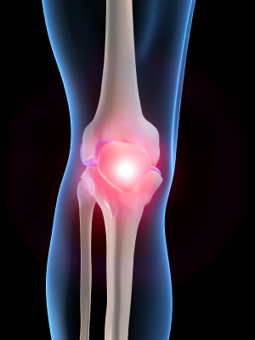

**We need volunteers with:**

* **osteoarthritis diagnosed in one or both knees or hips and no other leg injuries or disabilities**
* **fibromyalgia**

**You are ineligible to participate if you:**

* **have a severe psychiatric, cardiovascular, pulmonary, metabolic and/or neurological disease**
* **have another cause of chronic pain other than knee or hip osteoarthritis or fibromyalgia**
* **are unable to refrain from pain medication for 24 h prior to the study**

**For general enquiries, please contact Matthew Jones: matthew.jones@unsw.edu.au; 02 9385 9032**

**Matthew Jones**

**02 9385 9032**

**matthew.jones@unsw.edu.auu**

**Matthew Jones**

**02 9385 9032**

**matthew.jones@unsw.edu.auu**

**Matthew Jones**

**02 9385 9032**

**matthew.jones@unsw.edu.auu**

**Matthew Jones**

**02 9385 9032**

**matthew.jones@unsw.edu.auu**

**Matthew Jones**

**02 9385 9032**

**matthew.jones@unsw.edu.auu**

**Matthew Jones**

**02 9385 9032**

**matthew.jones@unsw.edu.auu**

**Matthew Jones**

**02 9385 9032**

**matthew.jones@unsw.edu.auu**

**Matthew Jones**

**02 9385 9032**

**matthew.jones@unsw.edu.auu**

**Matthew Jones**

**02 9385 9032**

**matthew.jones@unsw.edu.auu**

**Matthew Jones**

**02 9385 9032**

**matthew.jones@unsw.edu.auu**

**Matthew Jones**

**02 9385 9032**

**matthew.jones@unsw.edu.auu**

**Matthew Jones**

**02 9385 9032**

**matthew.jones@unsw.edu.auu**

**Matthew Jones**

**02 9385 9032**

**matthew.jones@unsw.edu.auu**

**Matthew Jones**

**02 9385 9032**

**matthew.jones@unsw.edu.auu**

**Matthew Jones**

**02 9385 9032**

**matthew.jones@unsw.edu.auu**

**Matthew Jones**

**02 9385 9032**

**matthew.jones@unsw.edu.auu**

**Matthew Jones**

**02 9385 9032**

**matthew.jones@unsw.edu.auu**

**The researchers involved are:**

**Mr Matthew Jones** (BExPhys, MSc, PhD candidate)

**Dr Ben Barry** (BSc(hons), PhD)

**Dr John Booth** (MAppSc, PhD)

**Associate Professor Janet Taylor** (MBBS, MBiomedE, MD)

The experiment will take place at *The University of New South Wales*, Randwick, NSW.

 